smart art
Take part in smart’s collaborative twitter picture project

To launch the smart urban stage, a pop-up showcase for ideas and innovation that will shape lives in cities of the future, smart will be inviting members of the public (you!) to take part in a unique smart art project. The smart twitter picture brings creativity and social networking together to create a dynamic, live design project..

The idea behind the smart twitter picture is simple: tweet your vision for the future to @smartfortwoUK and your suggestion will be drawn directly onto a smart fortwo electric drive, creating a limited edition print that captures the public’s imagination and their inspiration and ideas for the future.

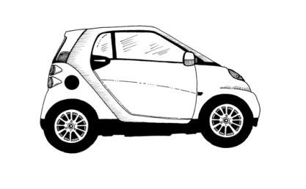
Illustrator, Johanna Basford, will be drawing the public’s tweets in her signature style of intricate hand penned curiosities over a two day period, 4th and 5th May from 8am to 8pm, live at the smart urban stage.

The brief for the tweets is simple - "What will the future look like?". smart wants to know what innovations and inventions will make your life easier, better or greener in the future. The best and most imaginative suggestions will be drawn on to smart’s ‘car of the future’ – the smart fortwo electric drive. Just tweet @smartfortwoUK and share your visions for the future, remembering to use the hashtag #smartpic.
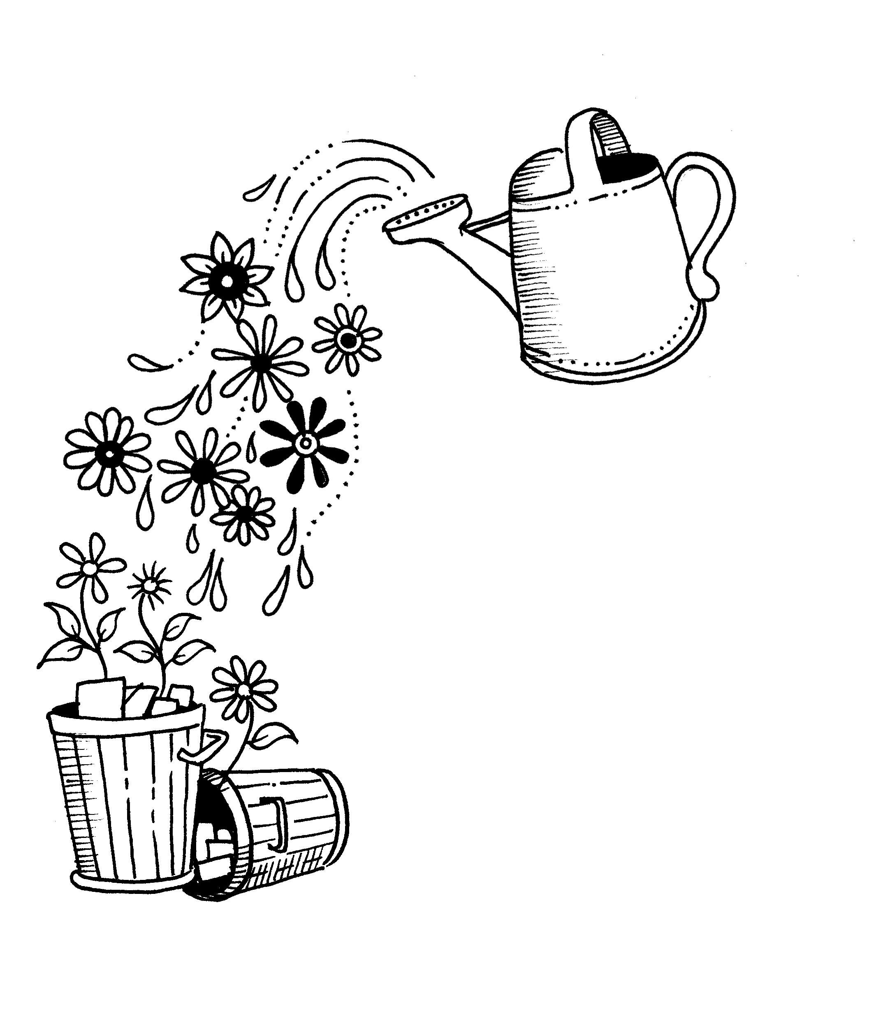
Get your creative thinking caps on, smart will be welcoming suggestions no matter how implausible they may seem – food for thought includes a robot that brings your tea and slippers in the morning or a magic watering can which makes oxygen producing flowers and plants grow from piles of rubbish.
The smart twitter picture activity will be taking place live at the smart urban stage on London’s Southbank, and will also be streamed live so that you can watch the collaborative art piece take shape at http://www.facebook.com/smartcaruk. TwitPic snap shots of the design in progress will be posted at 15 minute intervals throughout the two days to allow you to see the progress of the piece and to spot your suggestion as it appears in the artwork. The final car will be on display for the duration of the smart urban stage until May 16th at http://tinyurl.com/6575dyd

smart fans wanting to get hold of the completed artwork or the limited edition smart panels can register their interest by becoming a fan on the smart facebook page http://www.facebook.com/smartcaruk. An exclusive set of the panels will be auctioned for charity at the smart festival later in the year and the final illustration will be created into a 2D limited edition silk screen print of just 100 that will also be up for grabs.

Gary Savage, Managing Director at Mercedes-Benz UK comments: “smart twitter picture is great way to get the public thinking about, and sharing, their visions for the future. It’s fitting to use this to launch our smart Urban Stage, where we’ll be inviting customers and prospects along to take a test drive of the future.”
-ends-

For further information on the curators, exhibition or to arrange an interview please contact Lynsey Morris/Sarah Head at Fever on smart@feverpr.com or 020 7792 7488
Notes to editors:
How to get involved in the smart twitter picture project:
- Log on to http://www.twitter.com/smartfortwoUK
- Click on the box to Follow (if you are new to twitter, you'll need to sign up first)
- Ponder the possibilities of what you would like to see included.
- On Wednesday 4th May and Thursday 5th May 2011, tweet your suggestion @smartfortwoUK including the #smartpic
- Watch live on http://www.facebook.com/smartcaruk as your suggestion materialises in the design
- Retweet about the project to your heart's delight.
- Keep an eye on Twitter and the smart car UK facebook page http://www.facebook.com/smartcaruk for details of when the prints are put up for grabs and details on the smart festival
- Tell all your friends you are now a Published Creative Director and wow them with the beautiful print you helped create!
For more information on Johanna Basford - http://www.johannabasford.com/

The smart urban stage

The smart urban stage will take place 8am – 8pm (with selected late night events) between 3rd and 16th May at the Doon Street car park, London, SE1. http://tinyurl.com/6575dyd

For future updates on the smart urban stage and the ‘test drive with a difference’ as well as the smart festival join our facebook page at www.facebook.com/smartcaruk

